Title of the article in Spanish (Times new roman 12 pt) in normalized spelling and boldface type.

It should be concise, easy to understand and strictly correspond to what is presented in the article (maximum 15 words).

Author(s)
Author 1 Names and Surnames
Orcid https://orcid.org/0000-0002-6570-8574
Affiliation (University of origin)
Email

Author 2 Names and Surnames
Orcid https://orcid.org/0000-0002-6570-8574
Affiliation (University of origin)
Email

Author 3 Names and Surnames

Orcid https://orcid.org/0000-0002-6570-8574
Affiliation (University of origin)
Email

Date received: 2021-12-29
Date accepted for publication: 2022-03-18
Date of publication: 2022-06-30

In the authors' information: the full name of each author should be included without abbreviations, the Institution of origin followed by the initials by which the author is known, and e-mail address in lower case, City and Country. If the authors belong to a single institution, the institutional information common to all may be used.

Resumen

Times New Roman 12. Espaciado 1.0, sin sangría, texto justificado

El resumen tendrá como máximo 250 palabras (en español y en inglés). Debe reflejar fielmente el contenido del artículo. En él se describe, de manera concisa, el trabajo realizado. Esto es, detallar lo que se ha hecho, cómo se ha hecho, los resultados y su relevancia. No debe contener ecuaciones, figuras, tablas ni referencias. Su redacción debe estar en tercera persona. (Este Debe contener: fundamento, objetivo, metodología utilizada, resultados más relevantes y conclusiones que respondan al objetivo). Times New Roman 12. 1.0 spacing, no indentation, justified text.

The abstract will have a maximum of 250 words (in Spanish and English). It should faithfully reflect the content of the article. It should describe, in a concise manner, the work carried out. That is, it should detail what has been done, how it has been done, the results and their relevance. It should not contain equations, figures, tables or references. It should be written in the third person (It should contain: rationale, objective, methodology used, most relevant results and conclusions that respond to the objective).

Keywords: keyword 1, keyword 2, keyword 3.
keywords maximum 3 and in alphabetical order.

Key words: these allow the identification of the main topics or aspects of the article. They are also important for indexing in bibliographic databases. They should be between three and five, separated using the spelling and punctuation mark, semicolon ";" and in lower case, and may include short phrases describing significant topics of the article (using the terms of the UNESCO thesaurus by area of knowledge).
URL: http://vocabularies.unesco.org/browser/thesaurus/es/index

Article title in English (Times new roman pt12) in standard spelling and bold type

Abstract
Times New Roman 12. 1.0 spacing, no indentation, italic justified text.
The Abstract should be a coherent translation of the Abstract, not the product of an internet translator.

In the context of the article, font: times new roman, front size: 12 points, in italics, spacing: single spaced (1.5) for all the text with the sole exception of the Abstract and Abstract that should be single spaced (1.0), margins: top and left of 4 cm and bottom and right of 3 cm on the sides of the page, indentation: marked with the keyboard tab or 5 spaces and alignment of the text: justified. Pages should be letter size.

Keywords: keywords 1, keywords 2, keywords 3.

Introduction
Time New Roman 12. Spacing 1.5, Indentation first line 1.25.
In the Introduction the author offers a concise and analytical vision of the objective of the works and researches dedicated to the subject, as well as the background of the study. Development of the substantive theories or approaches presented by the research. In this case the introduction is the body of the article.
It will be brief, written in the present tense. It will provide the necessary explanation to show the state of knowledge on which the authors of the article based their work based on an exhaustive search of the published literature. In addition, its relevance should be made explicit (reference is made to the general scientific and research problem) and the importance of carrying out the study should be clearly justified. It should not contain tables or figures. It should include a final paragraph in which the main objective of the work is clearly stated.

Methodology
Time New Roman 12. Spacing 1.5, Indentation first line 1.25
In this part, the methods and methodologies used during the research, the approaches and paradigms to which the research responds, the instruments and techniques used are presented. At the same time, it includes the main findings and results achieved.
It should be written with verbs in the past tense. It will respond to the how, how much, where and when, so it will express the place where the research was carried out, the period of duration, the characteristics of the series studied, the sampling criteria and selection of the population used, the variables studied, the study design, the mode of data collection, the techniques used, both experimental and statistical, depending on the type of research. In general, all sufficient details should be provided so that the research can be repeated on the basis of this information. Approval by the Scientific Council and Ethics Committee of the institution where the research was carried out should be specified.

Results and discussion
Subtitles
Time New Roman 12. Spacing 1.5, Indentation first line 1.25.
In this type of research, the analysis strategies or analytical orientation assumed by the authors to present the results will be taken into account. According to the volume of information generated by the historical research, the most relevant knowledge should be selected, supported by narrative fragments or observations. Matrices, tables, diagrams, meaning maps and others can be included to explain the categories and facilitate the reading and understanding of the results.
After the title and summary, comes the shortest session of the article, but the most important because it is here where new knowledge is communicated. It should be written in the past tense. The results are only reported, not interpreted. These data should be presented in the text with the complement of tables and figures, which may be cited in the article, but the most relevant results should be stated. There should be a logical sequence in the text, with tables and figures.
Tables and graphs are key, if necessary, that is, when they objectively illustrate the results obtained (when the support of graphs, photos, charts or maps is required, they should not exceed two).

Figures and Tables

Figures and tables will only be used when the researchers consider them essential. They should be numbered in Arabic numerals, according to their order of appearance, and reference should be made to them in the text closest to the figure or table. Figures and tables should be clear. Photographs and figures must be original, in color, black and white or shades of gray, with a minimum resolution of 200 dpi (dots per inch). Captions should be clear and concise, able to explain their content, located at the top, left justified, as shown in Figure 1, and likewise for Table 1.

The title of the images should use font size 12, centered and in bold. The descriptive text of the images should use size 12 font without bold type. All images should be cited in the text with the same label used (Figure 1, Figure 2, etc.). An example of an image is shown in Figure 1.

3.1.1. Figure 1. The legend should clearly explain the corresponding figure.
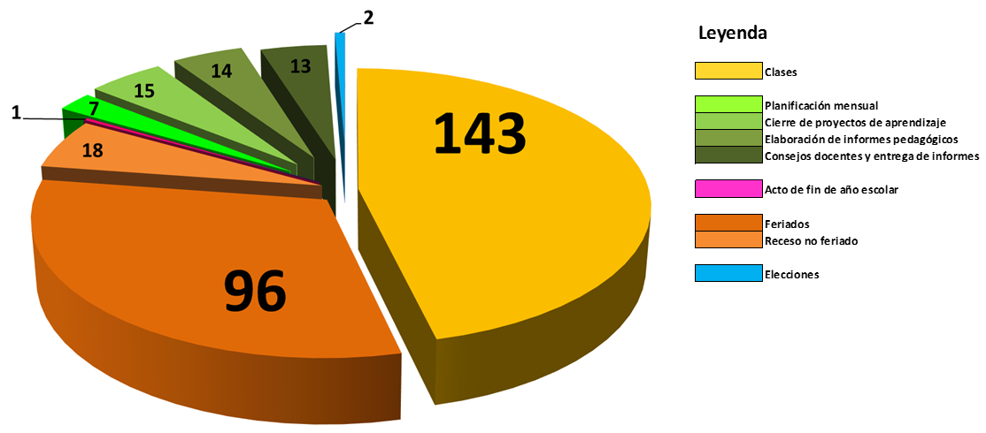
Fuente: Autor (año).

3.1.2. Tabla 1. Tipos de letra, justificación y tamaño.
Source: Author (year).

Table 1. Typefaces, justification and size.
Letter | Size | Letter | Justification
Title | 16pt | Arial | Centered
Authors | 10pt | Arial | Centered
Text | 10pt | Arial | Justified
Equation | 10pt | Arial | Justified
Figure | 10pt | Arial | Justified
Table | 10pt | Arial | Justified
Source: Author (year).

Conclusions
Time New Roman 12. Spacing 1.5, Indent first line 1.25.
Conclusions are mandatory. They should be characterized by clarity and synthesis. They will express the final balance of the research or the application of the knowledge or subject matter treated, the implications of the study and its relevance for the area of knowledge. The limits of the aspects on which the conclusion will be drawn will be set by the objectives of the article. In this section there is room for the questions that open up as a result of the study as possibilities for new research.
Information from the introduction or results should not be repeated. It should be written in the present tense. Unlike the Results, it is here where they are examined and interpreted, taking into account the main objective of the research, the hypothesis and the current state of knowledge of the subject under study. The conclusion should not become a review of the subject.

Authors should state their own views on the subject and highlight:

- The significance and practical application of the results.
- The novel and relevant aspects of the study.
- The relationship with similar publications and comparison between areas of agreement and disagreement.
- Indications and guidelines for future research.
- In the last paragraph, conclusions should be drawn, in accordance with the objective and type of study used in the research. Premature conclusions of work still in progress should not be made.
The Conclusion should state considerations on a possible inconsistency of the methodology (limitations of the study) and the reasons why the results may be valid.

References
Bibliographical references should follow APA 7th edition styles.
In the list, at the end, they are organized alphabetically and aligned to the left on the first line with upper and lower case letters and French indentation from the second line of the paragraph. References that are not cited in the article should not be included. Likewise, works under review, not yet published, should not be cited.
*No more than 15 citations should be included and 60% of them should be from the last five years.

The following general guidelines should be followed: First surname, First initial of first name (year). Title of the article in bold type. City and Country where it was published: Name of the Publisher, first and last pages, pages xx-xx. (The links or hyperlinks must work correctly and contain the cited information).
For journals, given their importance for citation indexes and Impact Factor calculations, the following will be cited: a). the author, with his/her last name and first initial of the first name. If there is more than one author, a comma will be placed between them, all up to a maximum of six, and more than six, the first six will be placed and ellipses will be added and the last author will be listed. After the last author, the year should be placed in parentheses and a period. b) Title of the article in its original language and in bold, with its own spelling and accents. The title should be followed by a period. c). Correct name of the journal in italics, e). volume number and (number of the edition). The separation between this paragraph and "f" should be made with a comma, f). first and last pages, separated by a hyphen and the ISSN. (for electronic journals, the electronic address or DOI should be included; for printed journals, the ISSN, City, Country: and Publisher should be included).
*Self-citations of the same author are strictly forbidden.

Reference example for electronic journals:
Martinez, O. (2019). Epistemological considerations. Scientific Journal, 4(11), 7-25, e-ISSN: 2542-2987. Retrieved from:
https://doi.org/10.29394/Scientific.issn.2542-2987.2019.4.11.0.7-25

Reference example for print journals:
Martinez, O. (2019). Epistemological considerations. Revista Scientific, 4(11), 7-25, ISSN: 2542-2987. Barinas, Venezuela: Instituto Internacional de Investigación y Desarrollo Tecnológico Educativo - INDTEC.

Example of reference for books:
Behar, D. (2008). Research Methodology. Introduction to Research Methodology. ISBN: 978-959-212-783-7. Colombia: Editorial Shalom.

The textual or direct cites:
- These reproduce the material exactly, without changes or additions. The author, year and page number should be indicated. If the quoted source does not have pagination, then the paragraph number is written. If the cites has less than 40 words, it is placed as part of the body of the text, between quotation marks and at the beginning the first surname of the Author and the year in parentheses, and at the end of the cites in parentheses, the page number is indicated. In case of forty (40) or more words, they will form a separate paragraph with indentation of five spaces in the left and right margins, without quotation marks and written in single line spacing.

*Author (year): citation (page xx).
- If an author is paraphrased, the corresponding credit must be given. In any case, always provide the author, the year and the specific page of the cited text, and include the complete reference in the reference list.
*All citations should be incorporated into the text and not at the foot of the page, maintaining the structure used.

Example 1. (If the cite is less than 40 words):
Subsequently, Senge (1999): who states that "systems thinking is also a sensitivity to the subtle interconnections that give living systems their unique character" (p. 91).

Example 2. (in case of having forty 40 or more words):
Subsequently, Senge (1999), argues that:
Today systems thinking is needed more than ever because complexity overwhelms us, Perhaps for the first time in history, humanity has the capacity to create more information than anyone can absorb, to encourage greater interdependence than anyone can manage, and to drive change with a speed that no one can keep up with (p. 92).

Indirect cites or paraphrases
- In these cases, the idea of another person is reproduced in his or her own words. They follow the rules of textual citation, except for the use of quotation marks and quotations in a separate paragraph.
*In the only cases where the page number can be deliberately omitted is in paraphrases and this is when several ideas expressed throughout a work are being summarized and not a particular idea easily found in the cited source.

*Submission of an article does not guarantee that it will be accepted. All previous work to be published will be reviewed by blind peers.

